

CONNECTHUB

Contact Manager Backend System



Technology Stack:
Node.js | Express.js | Thunder Client | MongoDB | JWT

TABLE OF CONTENS
  - Project Overview

  - Objectives

  - Technology Stack

  - System Architecture

  - Database Design

  - API Endpoints

  - Features

  - Implementation

  - Project Execution

  - output screenshots 11.conclusion

Project Overview
ConnectHub Contact Manager is a backend REST API application developed using Node.js and Express.js. The main purpose of this application is to provide a simple, secure, and efficient way for users to manage their contact information in a centralized system. In today’s digital world, managing contacts manually can be difficult and time-consuming. This system solves that problem by providing an organized platform where users can store, update, search, and delete contact details easily.

The application includes a secure authentication system that allows users to register and log in safely. Authentication ensures that only authorized users can access and manage their personal contacts. Passwords and sensitive information are handled securely to protect user data. After successful login, users can perform various operations on their contacts through the REST API.
The system supports CRUD operations (Create, Read, Update, and Delete) for contact

management. Users can create new contacts by adding details such as name, phone number, email address, and other relevant information. They can also view the list of saved contacts, update existing contact information, or delete contacts that are no longer needed. This functionality makes contact management flexible and efficient.
To improve usability, the application also provides a fast search feature that helps users quickly find specific contacts from their contact list. Instead of scrolling through a long list, users can search by name or other details to locate contacts instantly. This feature saves time and enhances the overall user experience.
The backend of the application uses MongoDB as the database for storing contact information securely. MongoDB is a powerful NoSQL database that allows flexible data storage and fast data retrieval. By integrating MongoDB with Node.js, the system ensures reliable data management and efficient performance.
Overall, the ConnectHub Contact Manager REST API is designed to be a scalable and secure backend system that simplifies contact management. It provides essential features such

as authentication, CRUD operations, fast searching, and secure data storage. This project demonstrates the practical use of modern web development technologies like Node.js, Express.js, and MongoDB to build a functional and efficient backend application.

Objectives
- Provide centralized contact management

- Implement secure authentication

- Allow CRUD operations for contacts

- Enable fast search functionality

- Store data securely in MongoDB

- Implement contact sorting and filtering options

Technology Stack
Technology Purpose

Node.js Backend runtime

Express.js API framework

MongoDB Atlas Cloud database

Mongoose ODM for MongoDB

JWT Authentication

Thunder Client API testing

System Architecture
The backend follows MVC architecture. Routes handle requests, controllers contain business logic, models define MongoDB schema and middleware handles authentication.

Database Design
Two main collections are used in MongoDB:
  - Users Collection – name, email, password, timestamps.

  - Contacts Collection – userId, name, email, phone, tags, timestamps.

API Endpoints

Method | Endpoint | Description
POST | /api/auth/register | Register new
 |  | user
POST | /api/auth/login | Login user
GET | /api/auth/me | Get current user
POST | /api/contacts | Create contact
PUT | /api/contacts/:id | Update contact
DELETE | /api/contacts/:id | Delete contact
GET | /api/contacts/search | Search
 |  | contacts

- Features
  - User authentication with JWT

  - Password hashing using bcrypt

  - Create, update and delete contacts

  - Search contacts using query

  - MongoDB cloud database storage

Implementation
The backend server runs on port 5000 and connects to MongoDB Atlas. API endpoints are tested using Thunder Client extension in VS Code.

- Project Execution:

Execution Steps
- Open the project folder in the terminal.
- Make sure you have a start script in the package.js file.
- Use the command npm start to start the server.
- You will the Running on PORT message on the successfully starting the server.
- You will also see the database connected message if the database is connected successfully.
- Use the Thunder client or Postman
for using the created api’s.

Output Screenshots
- Register Api
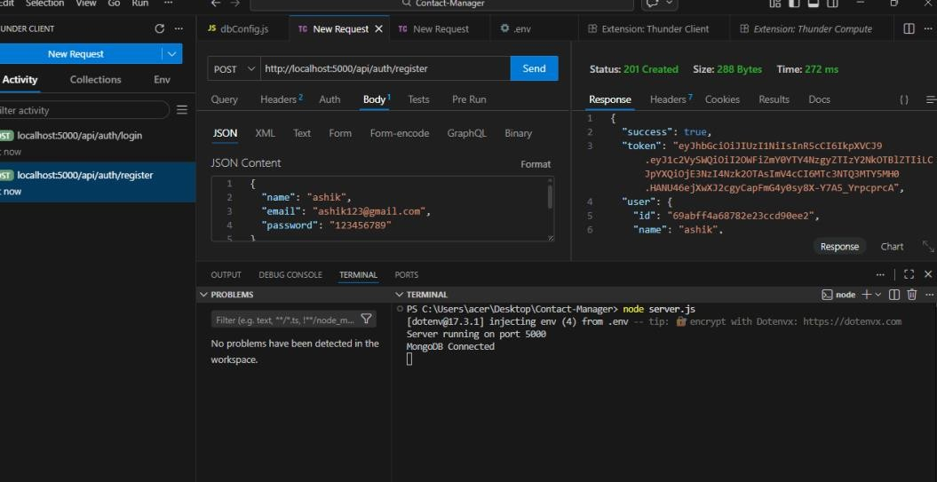

- Login Api
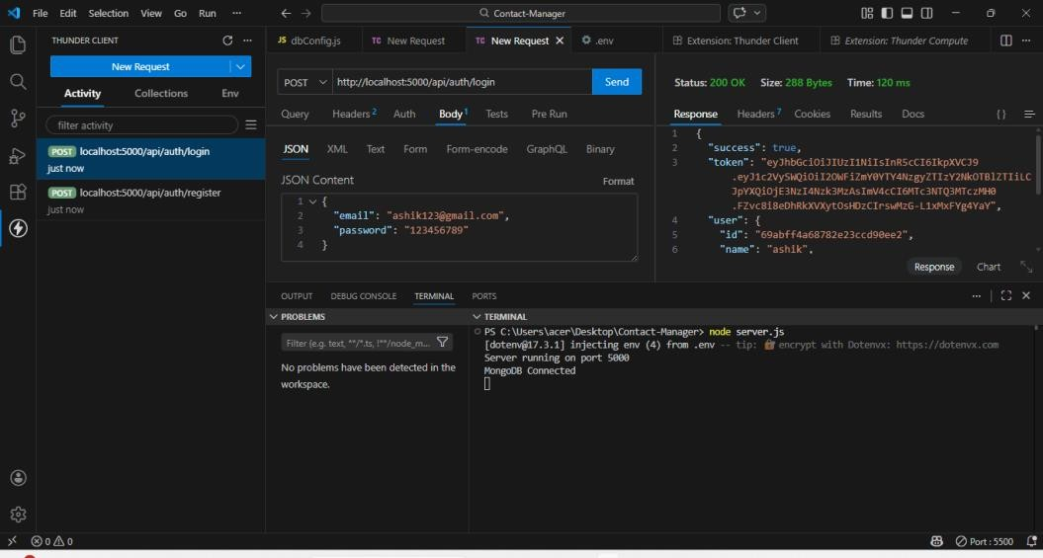

- Create New Contact
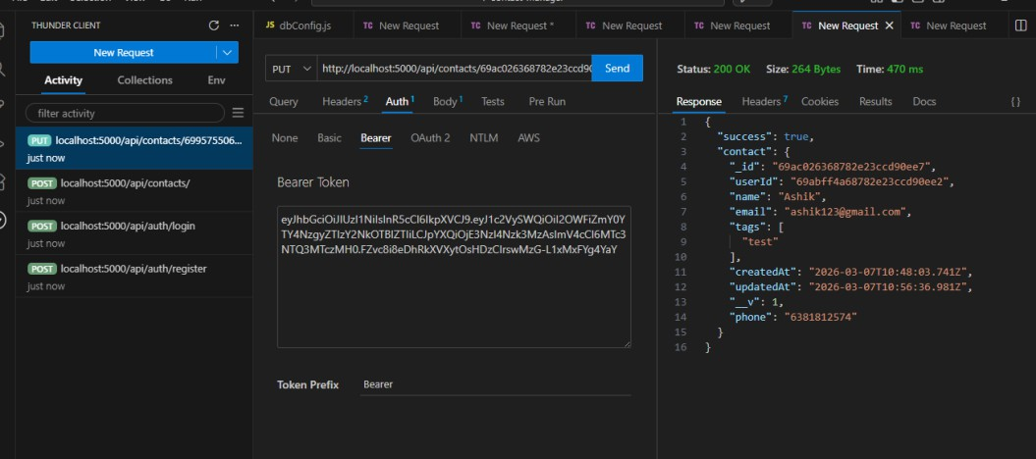

- Update Contact
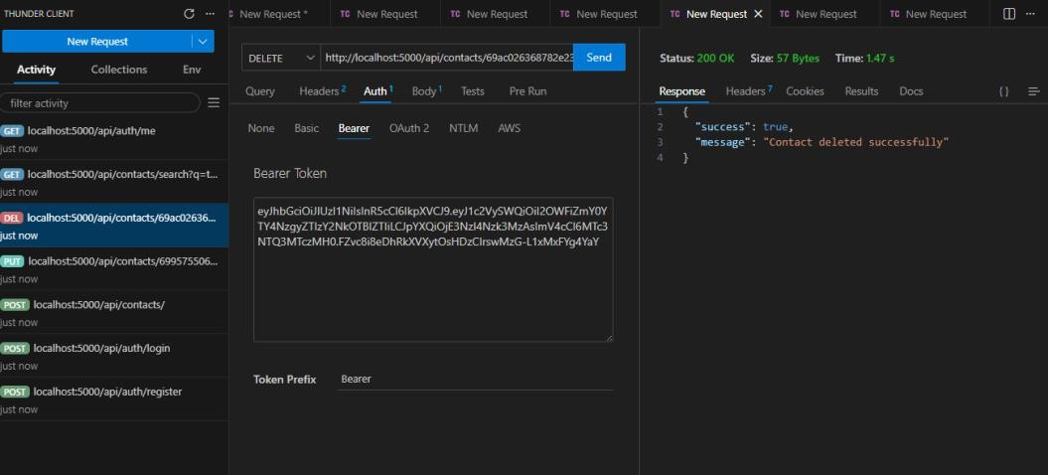

- Delete Contact
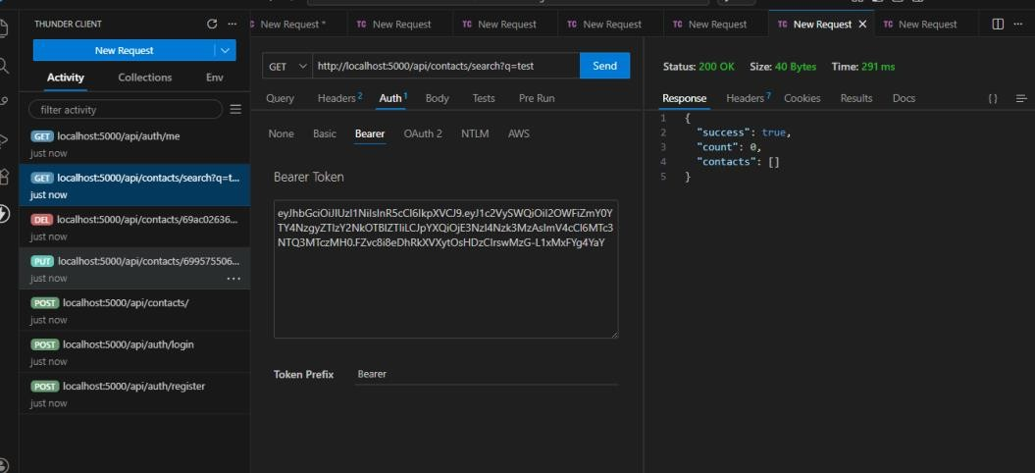

- Search Contact


Mongodb execution output:

- output
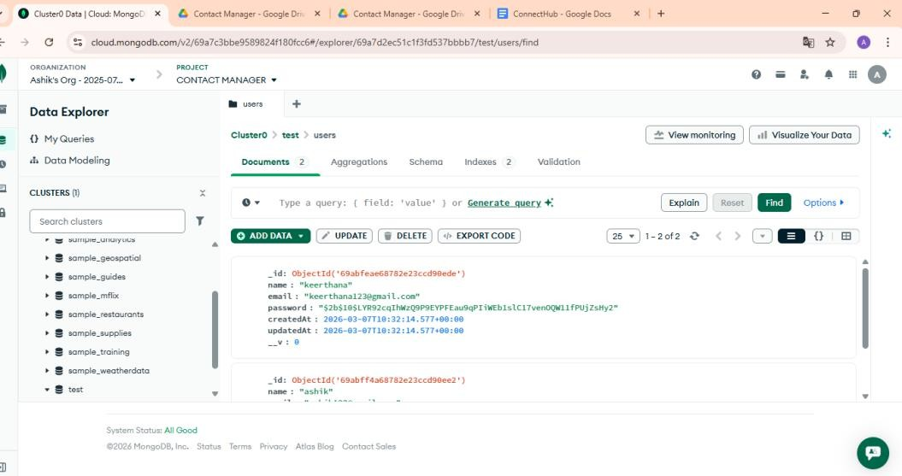

- output
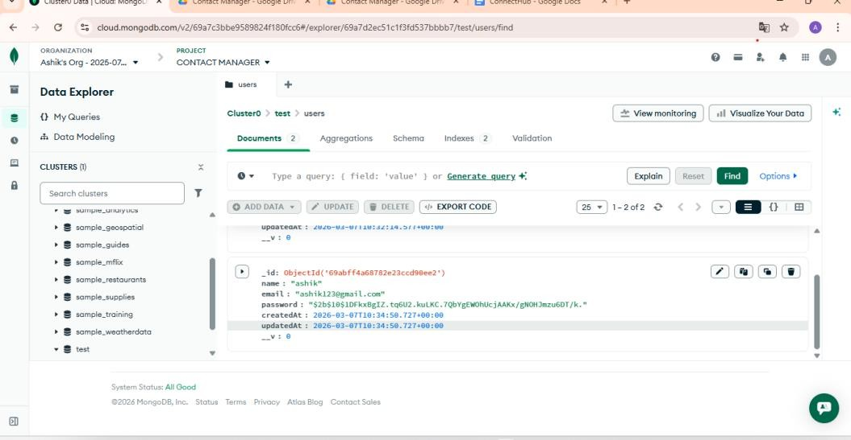

10. Conclusion
The ConnectHub Contact Manager backend demonstrates the implementation of REST API development using Node.js, Express.js, and MongoDB with secure authentication and efficient contact management. This project shows how modern backend technologies can be used to build a reliable and scalable system for managing user data. By integrating authentication and database management, the system ensures that only authorized users can access and manage their contacts.
The application successfully implements essential features such as user registration, login authentication, and CRUD operations for contacts. These features allow users to easily create, view, update, and delete their contact information in a structured and organized way. The inclusion of a search functionality further improves the usability of the system by allowing users to quickly find specific contacts.

MongoDB plays an important role in storing and managing the contact data securely and efficiently. The use of RESTful API design makes the system flexible and easy to integrate with different frontend applications such as web or mobile interfaces. This makes the backend highly reusable and scalable for future development.
Overall, the ConnectHub Contact Manager backend project demonstrates practical knowledge of backend development concepts, including API creation, database connectivity, authentication, and data management. It also provides a strong foundation for building more advanced applications with additional features in the future.

